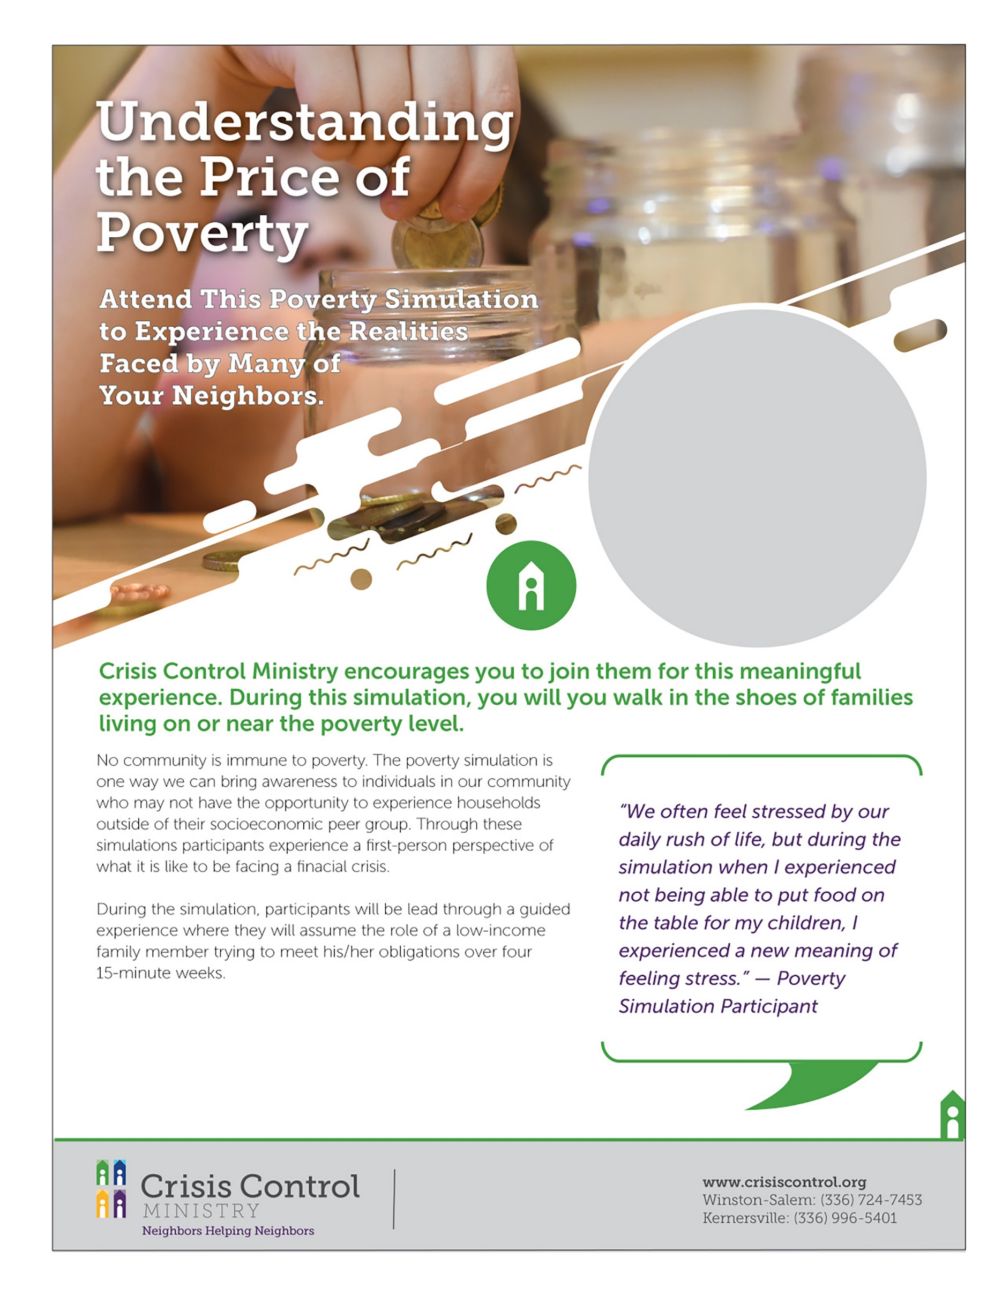

**TEXT BLOCK:**

**Information about where to register, and**

**contact information.**

**YOUR**

**LOGO**

**DAY of WEEK**

**MONTH, DAY**

**TIME**

**LOCATION**

ADDRESS LINE 1

ADDRESS LINE 2